MASCHERPA Audric ROB 3 2022 / 2023

**POLY-SNAKE**

**Weekly report n°7 from 09/12/22 :**

Figure 7.1

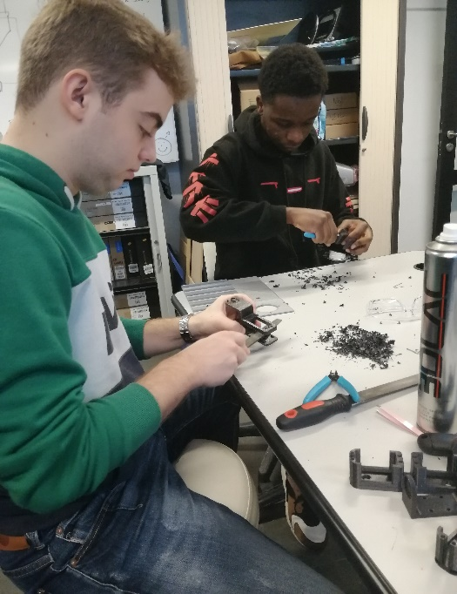

Following the previous session where we were able to finalize the programming of the snake's movement, this session focused on testing the program on a large scale with almost all the modules without counting the head and tail.

Thus, the first hour of this session was focused on the improvement of the 3D printing launched the day before which, due to poor printing quality, had some defects such as flat surfaces to be filed on figure 7.1.

Once this step was completed, we were able to move on to testing the movement of the snake. Indeed, once the pieces are assembled, we have carried out various tests on the movement of our robot in order to modify the speed of the motors, their angle of inclination, etc… directly on the program. All in order to have the movement the as fluid as possible and closest to a real snake.

At first, we tested the proper functioning of the motors and whether they responded well to the instructions imposed.

Here a Youtube link of the servo test video : <https://www.youtube.com/watch?v=MFZg65ag1Ys>

Here a Github link of the program to test the servos : <https://github.com/YOUSSNDR/PolySnake/blob/d56cbe0c96f5da3d0bfc388265c8761a218193a4/programmes/servomoteurs/D%C3%A9placement/servos_testing/servos_testing.ino>

Then finally we were able to test the movement of the PolySnake with 6 different modules.

Here a Youtube link of the test : <https://www.youtube.com/shorts/CUl1Hz0VQxA>

Here a Github link of the program of the test : <https://github.com/YOUSSNDR/PolySnake/blob/main/programmes/servomoteurs/programme%20fonctionnel/version%20fonctionnelle/version%20fonctionnelle.ino>